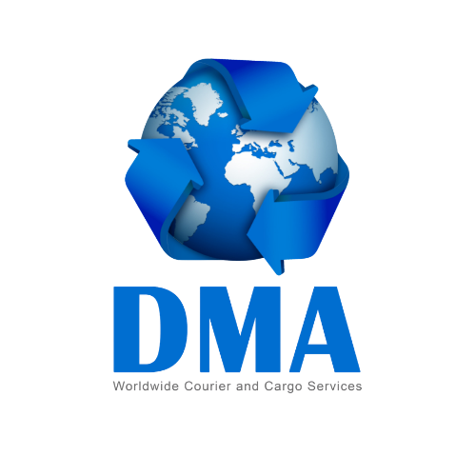
DMA AIRFREIGHT PROCEDURE & TERMS AND CONDITIONS
Head Office:
Unit 1, Greenhill House, 26 Greenhill Crescent
Watford Business Park, Watford, WD18 8JA

Tel: 0203 887 6787 / 07958 050311
Email: info@dmalogistics.co.uk

Web: www.dmalogistics.co.uk

✈️ AIRFREIGHT PROCEDURE
Once you provide the weight and dimensions of your package 📦, we will send you a provisional quotation.
The final quotation will be confirmed after we receive and check the parcel.
If you are happy with the quote, we will arrange collection.
Depending on your postcode and urgency, we will either:
Collect the parcel ourselves, or
Arrange a local courier (collection cost remains the same)
After receiving your package:
A final invoice will be issued
Payment can be made via phone or bank transfer
Once payment is received, your parcel will be dispatched on the next available air shipment

🔗 Tracking: https://dmalogistics.co.uk/tracking/

You can track your shipment until it reaches its destination.

⚖️ WEIGHT CALCULATION
1. Actual Weight
The actual weight is the physical weight shown on the scale.
2. Volumetric Weight
Volumetric weight is based on the size of the parcel.
Formula:
Length × Width × Height (cm) ÷ 6000 (Airfreight)
or ÷ 5000 (Courier services like DHL, FedEx, TNT)
Example:
60 × 40 × 40 ÷ 5000 = 19.2 kg
***Important
Shipping charges are based on the higher of:
Actual weight
Volumetric weight
🚪 DOOR-TO-DOOR SERVICE
To proceed, you must provide:
Detailed packing list (all items listed clearly)
Shipper & Consignee ID copies
Valid contact numbers
⚠️ Please note:
No responsibility for missing undeclared items
Any customs duty, taxes, or demurrage charges must be paid by the customer
Full payment must be made before dispatch
Packing List Requirements
List all items with quantity and value
Add extra sheets if needed
Sign and date the declaration
Incomplete lists may result in customs charges or delays

📦 DOOR-TO-DEPOT SERVICE
Your shipment will be sent to a custom bonded warehouse, where you/consignee can clear it.
⚠️ Must be arranged before shipment leaves the UK
Benefits
Lower shipping rates
Possibility to reduce or avoid customs duty (subject to eligibility)
Parcel opened in your presence
🚫 RESTRICTED ITEMS
(Please contact DMA team before packing any uncertain items)

💰 CUSTOMS DUTY & DESTINATION CHARGES
Customs duties are charged by Sri Lanka Customs
DMA is not responsible for these charges
Charges may apply if:
Taxable items are included
Commercial goods or quantities are shipped
⚠️ Customs charges are NOT included in our prices

For door-to-door shipments:
Individual customs receipts may not be available
If you require a receipt:
➡️ Choose Door-to-Depot service

📜 TERMS & CONDITIONS
Payment Policy
All shipments must be fully paid before processing
(Effective from 15 November 2025)

Late Payments
Shipments will be held in warehouse
Delayed payments may cause shipment to miss scheduled dispatch
Invoicing
Invoices will be issued within 24 hours of collection

Customer Support

If you experience payment issues:

Please contact us to discuss solutions
Alternative arrangements may be considered
🔍 TRACKING
Track your shipment at:
www.dmalogistics.co.uk
Enter your invoice number for updates.

📞 CONTACT US
0203 887 6787
07958 050311
info@dmalogistics.co.uk

